Title | CLIMATE CHANGE IMPACT ON RC BRIDGES: AN INTEGRATED MACHINE LEARNING-BASED APPROACH FOR SEISMIC RESILIENCE ASSESSMENT
Author(s) | N R Chirdeep, Mayank Gangwar, Shivang Shekhar, and A Bahurudeen
Journal | Journal of Structural Engineering
Table S1. Logistic regression coefficients corresponding to parameterized fragility models for critical bridge components response of MSSS concrete girder bridge class.
Components or System | Damage States | β₀ | β_{IM} | β₁* | β₂† | β₃ | β₄ | β₅ | β₆
System | Slight | 12.208 | 3.883 | 0.361 | 0.055 | -1.640 | 0.019 | -0.940 | 0.044
 | Moderate | 3.048 | 3.485 | 0.041 | 0.012 | 1.246 | 0.006 | -1.329 | 0.219
 | Extensive | 2.198 | 2.971 | 0.046 | 0.036 | 1.088 | 0.007 | -1.398 | 0.173
 | Complete | 1.758 | 2.473 | 0.052 | 0.061 | 1.071 | 0.003 | -1.487 | 0.120
Pier | Slight | 11.950 | 3.829 | 0.370 | 0.056 | -1.504 | 0.019 | -0.942 | 0.041
 | Moderate | 2.856 | 3.334 | 0.079 | 0.012 | 1.194 | 0.006 | -1.349 | 0.218
 | Extensive | 2.089 | 2.929 | 0.062 | 0.040 | 1.124 | 0.006 | -1.423 | 0.172
 | Complete | 1.750 | 2.463 | 0.058 | 0.065 | 1.095 | 0.002 | -1.512 | 0.119
Bearings | Slight | -0.349 | 4.036 | -0.290 | 0.001 | -0.100 | 0.002 | 0.212 | 0.134
 | Moderate | -2.359 | 4.317 | -0.253 | 0.002 | 0.096 | 0.003 | 0.187 | 0.129
 | Extensive | -3.575 | 5.485 | -0.262 | 0.005 | -0.282 | -0.002 | 0.300 | 0.144
 | Complete | -4.460 | 5.847 | -0.267 | 0.006 | -0.380 | -0.003 | 0.231 | 0.141
Abutments | Slight | -3.500 | 7.249 | -0.598 | -0.009 | 0.071 | 0.010 | 0.341 | 0.353
 | Moderate | -14.732 | 8.766 | -1.240 | 0.011 | 3.144 | -0.018 | 0.450 | 0.468
 | Extensive | -102.566 | 0.000 | 0.000 | 0.000 | 0.000 | 0.000 | 0.000 | 0.000
 | Complete | -102.566 | 0.000 | 0.000 | 0.000 | 0.000 | 0.000 | 0.000 | 0.000
Note: β₁*, β₂†, β₃, β₄, β₅, and β₆ corresponds to logistic regression coefficients for shear modulus of elastomeric bearing (in MPa), mass loss of longitudinal steel rebar, longitudinal reinforcement ratio, mass loss of transverse steel rebar, aspect ratio, and length of deck span (in m).
Development of GUI for Proposed ML-based Seismic Resilience Assessment:
The development of seismic fragility curves is a crucial step in seismic resilience assessment of RC bridges. To estimate the parameters required for developing fragility curves, the conventional method often involves development of robust finite element model to analyze and estimate the seismic demand parameters of various bridge components, followed by estimating the capacity limit states. Moreover, this approach is time-consuming and necessitates expertise in numerical simulations. To facilitate convenient and prompt estimation of seismic fragility curves for various bridge components, the proposed parameterized fragility and resilience functions are utilized to develop an interactive MATLAB GUI program to enable its practical applicability, as depicted in Figure 1. The development of seismic fragility curves of various bridge components requires 6 input variables. It is essential to acknowledge that these input parameters must adhere to the numerical ranges that are shown in Figure 1. After filling out the input parameters, clicking the “PREDICT” button will activate the proposed model to generate fragility curves of various bridge components and bridge system. This GUI offers a rapid, accurate, and efficient method for developing seismic fragility and resilience curves. The program is publicly accessible at the following URL: https://github.com/chirdeepnr/GUI_for_Sesmic_Fragility.
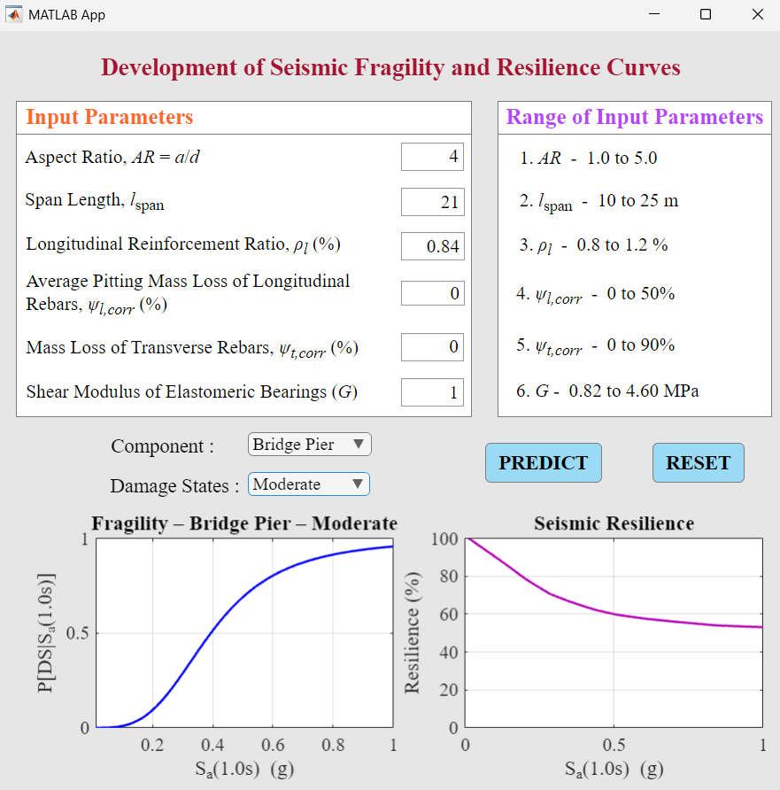

Figure 1. Graphical user interface (GUI) of the proposed model to develop seismic fragility and resilience curves

Research Scholar, Department of Civil Engineering, Birla Institute of Technology and Science Pilani, Hyderabad Campus, Hyderabad, Telangana 500078, India. ORCID: https://orcid.org/0000-0003-3097-866X. Email: p20200429@hyderabad.bits-pilani.ac.in
Research Scholar, School of Civil and Environmental Engineering, Indian Institute of Technology Mandi, Mandi, Himachal Pradesh 175075, India. ORCID: https://orcid.org/0009-0000-8347-2166. Email: d22081@students.iitmandi.ac.in
Assistant Professor, School of Civil and Environmental Engineering, and Joint Faculty, Centre for Climate Change and Disaster Management, Indian Institute of Technology Mandi, Mandi, Himachal Pradesh 175075, India. ORCID: https://orcid.org/0000-0003-0474-4202. Email: shivang@iitmandi.ac.in (Corresponding Author). TEL: +91-81930 48583. FAX: +91-1905 267724.
Associate Professor, Department of Civil Engineering, Birla Institute of Technology and Science Pilani, Hyderabad Campus, Hyderabad, Telangana 500078, India. ORCID: https://orcid.org/0000-0002-8300-2321. Email: bahur@hyderabad.bits-pilani.ac.in

